**UNIT-1**

**Worksheet-2**

**1**.The Regular expression101*10 is generically stated as

**(i) Set of all strings starting and ending with ‘10’ and any number of 1’s in between ‘10’.**

(ii) Set of all strings starting with ‘10’ and ending with ‘10’.

(iii) Set of all strings starting with ‘10’ and ending with ‘10’ and ‘1’ in between them.

(iv) Set of all strings starting with ‘10’ and ending with ‘10’ and ‘10’ in between them.

2. Choose the RE for a language of any combination of 0’s & 1’s containing 1001 as a substring

(i) L=(01)*1001(01)*

**(ii)L=(0+1)*1001(0+1)\***

(iii)L=(01)*1001(0+1)*

(iv)L=(0+1)*1001(01)*

3. Which pair is equivalent regular expression?

(i) (ab)* and a*b* (ii) a(aa)* and (aa)*a (iii) a+ and a*a

a. Only (i)

b. Only (ii)

**c. (ii) and (iii)**

d. (i)(ii) and (iii)

4. NFA’s accept

1. **Regular Languages**
2. More languages than a DFA can accept
3. Languages that are not regular
4. Context Free Languages

5. Which one of the following languages over the alphabet {0, 1} is described by the regular expression (0 + 1) *0(0 + 1) *0(0 + 1) *?

(a) The set of all strings containing the substring 00

(b) The set of all strings containing at most two 0’s

**(c) The set of all strings containing at least two 0’s**

(d) The set of all strings starting and ending with 0 or 1

**Part-B**

1.Describe the Language generated by the following Regular Expression (0)*(101)*11.

2. **Identify the Regular Expression for the following:**

A language consists of any combination of 0’s & 1’s, beginning and ending with the string ‘01’.

3.Justify whether Regular expression exist for the following scenario.

Seetha wants to write the Regular expression for the set of all strings which contain repeated substrings of any length>1[E.g., “aba” Substring ‘a’ Repeats].

4.Recognize the term Epsilon (ε) – closure. Identify the Epsilon (ε) closure of the state qo in the following NFA.

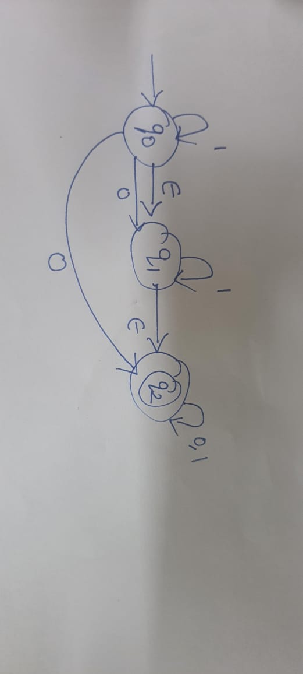

5.Memorize the 5 tuple structure of DFA and NFA.